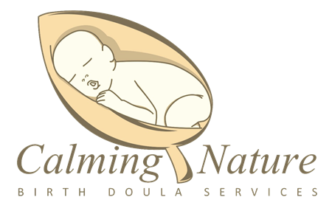
4/1//2022
Dear Sir/Madam,
My name is Shannon Johns. I am the owner and founder of the Calming Nature Doula Service & Center. Our organization consists of Certified Birth Doulas, Postpartum Doulas, and Certified Lactation Counselors. We advocate, educate, provide physical, emotional and motivational support to expectant women in the Western New York area. Our mission is to reduce the infant mortality rate, increase the breastfeeding rate, eliminate the inequalities and racial disparities in the low-income and African American community.
We are happy to finally announce the return of our bi-annual, Brunch for Bumps event. This event is for expectant, soon to be expectant, and postpartum parents learning what services and options are available to them during pregnancy, childbirth, the postpartum period and beyond. There will be several presentations given by local professionals on topics regarding pregnancy, birth, and postpartum care. There will also be multiple vendors in attendance to offer products and services to all attendees. Every mother that attends receives a gift bag of useful items and products around prenatal, postpartum and newborn care. Additionally, every dad will receive a gift bag of dad items to congratulate them on becoming a dad.

Brunch for Bumps is scheduled for:
Date: Sunday June 12th, 2022
Time: 11:00 am to 2:00 pm
Location:
The Foundry Suites
1738 Elmwood Ave
Buffalo, New York 14207

Our efforts to help reduce the infant mortality rates can’t take effect unless we have the support of members of the community.
If there are any questions please contact me directly at 716-768-4758 or info@calmingnaturedoula.com. I look forward to hearing from you soon. Thank you in advance for your time and generosity.
Sincerely,

Shannon Johns CD(DONA), CLC
Ceo
Calming Nature Doula Service & Center
223 Grant St
Buffalo, NY 14213

Participation Level:
Platinum: $500
- Full page ad in our resource guide
- Logo ad w/hyperlink from our event website direct to yours.
- Brunch for 2 staff members during the event.
- Prime spot exhibitor table.
- 2 free tickets to the event.
- Social media and Live blast prior to and during the event
- Inclusion in our radio ad
- An item of your choice added to the goody bags given to all attendees.
Gold: $400
- Half page ad in our resource guide.
- Logo ad w/hyperlink from our event website.
- 1 Exhibitor table
- Brunch for 2 staff members during the event.
- 1 free ticket to the event.
- Social media blast from our social media pages.
- An item of your choice added to the goody bags given to all attendees.
Silver: $300
- Quarter page ad in our resource guide.
- Logo ad w/hyperlink from our event website.
- 1 Exhibitor table
- Brunch for 2 staff members during the event.
- An item of your choice added to the goody bags given to all attendees.
Vendors: $100
- 1 Exhibitor table
- Brunch for 1 staff member during the event.
- An item of your choice added to the goody bags given to all attendees.
Swag Bags Only: $50
- An item of your choice added to the goody bags given to all attendees.

